|  |  |
| --- | --- |
| Medical Appointment Chatbot Proposal | 219181450 K Mtshazo  219957505 S Sipopo  219958064 NG Mnguni |

Contents

1. Introduction 2

2. Problem Statement 2

3. Purpose 2

4. Project Description 3

4.1. Project Goal 3

4.2. Project Outputs 3

5. Alternatives Solutions 3

6. Expected Benefits 4

7. Mission Critical System 4

8. Proposed Timetable 5

8.1. Work Breakdown structure 5

8.2. PERT Chart 6

8.3. Gantt Chart 7

9. Modules/Users 8

9.1. Use Case Diagram 8

9.2. State Chart 9

9.3. Data Flow Diagram 9

10. Requirements 10

10.1. Software Requirements 10

10.1.1. Functional Requirements 11

10.1.2. Non-Functional Requirements 11

10.2. Hardware Components 12

11. Advantages 12

12. Disadvantages 13

13. Conclusion 14

14. References 14

# Introduction

It is quite apparent that as time changes health is imperative in our daily lives. We’ve had a pandemic that has shown us that health is our greatest gift and should be treasured. Seeing a doctor is a must, but you ought to make an appointment to see that doctor.

When patients are too busy, the last thing they want to do is pay a visit to the doctor’s clinic in person, to queue in a long line and make an appointment.

Hence it is important to work alongside an Appointment Chatbot, that will help eliminate all these discomforts of visiting a doctor or waiting in line to make an appointment.

This system provides an easier way for rescheduling, cancellation and booking an appointment. And relieves workers of tedious tasks and help the company with utilizing its workers in an effective way.

A chatbot is software that is designed to interact like a human. Whenever a visitor visits your website. (Jake Frankenfiel, 2022)

# Problem Statement

Artificial intelligence, chatbot is a technology that makes interactions between man and machines using natural language possible. From literature, we found out that in general, chatbot are functions like a typical search engine. Although chatbot just produced only one output instead of multiple outputs/results, the basic process flow is the same where each time an input is entered, the new search will be done. Nothing related to previous output. This research is focused on enabling chatbot to become a search engine that can process the next search with the relation to the previous search output. In chatbot context, this functionality will enhance the capability of chatbot’s input processing. (Amplework Software pvt, 2021)

# Purpose

It is only natural to be met with raised eyebrows while mentioning healthcare and AI chatbots in one sentence. But chatbots are quite the opposite of a threat for the medical industry. They are built to perform basic and repetitive tasks that can streamline the day-to-day functioning of a medical practice. Most of all, they assist with appointment scheduling.  
  
Think of medical chatbots as virtual assistants for your clinic, hospital, or healthcare centre. They’re inexpensive, easy to add to your website, and highly efficient at what they do. (Konstantin Kalinin, 2020)

The overall purpose of is to minimize while booking appointments such as double bookings and incorrect time selection, minimise driving for enquires, familiarize people to machine interactions, decrease lines and cluster in medical canters, increase the dependency technological assistance by medical staff.

# Project Description

## Project Goal

A medical chatbot facilitates the job of a healthcare provider and helps improve their performance by interacting with users in a human-like way. There are countless cases where intelligent medical chatbots could help physicians, nurses, therapists, patients, or their families. They can step in and minimize the amount of time they spend on tasks like:

* providing health-related information to users
* guidance for patient
* Maintaning multiple patient interaction
* connecting people and organizations with first responders
* Conduct tedious repetitive tasks.
* FAQ-type queries (contact details, directions, opening hours and service/treatment details)

It’s important to note that despite the fact that chatbots can offer valuable facts and symptoms, they aren’t qualified to give an official diagnosis. The main premise behind these talking or texting smart algorithms is to become the first point of contact before any human involvement is needed.(Abhinav Girdhar, 2022)

## Project Outputs

1. **Immediate access to health care**

A chatbot quickly assists you with any front desk related issue but not all.

1. **Health monitoring and additional information**

Patients can query medical conditions and have easy communication with their respective doctors for monitoring of health.

1. **Easy-to-use for doctors and patients**

Conversational interfaces are very accessible and don’t have the complexities and learning curve typically associated with new technology.

1. **Scalability**

With technology, healthcare companies can deliver customer service without requiring additional resources (like human staff).

1. **Convenient for a mobile-first consumer base**

Mobile phones are one of the preferred methods of communication with brands, e specially for certain demographics. Medical institutes can cater to that audience.

1. **Improved patient satisfaction**

These applications help overcome staff shortages with robotic assistance. No issue will be left unattended. (Abhinav Girdhar, 2022)

# Alternatives Solutions

Alternative solutions to the modern chatbot box are quiet limited including:

* 1. Physically going or calling about booking, cancelling, or queering an appointment
  2. Physically talking to a doctor about one’s medical condition
  3. Going to companies’ website
  4. Google/research solutions and symptoms

# Expected Benefits

* **Reduced waiting times:**

Chatbots in the healthcare system prevent long hospital queues by providing patients with instant answers.

* **Massive reduction care costs:**

Chatbots help to significantly reduce patient cost to make schedule, reschedule and cancel appointments, also reducing business operational costs.

* **Timely medical advice**:

Care chatbots help provide instant information, which can help person.

* **Ease the burden on doctors:**

It is nearly impossible for doctors to address all patients on a tight schedule, whereas medical chatbots are accessible 24*7.

* **Real-time interaction:**

Chatbot provides immediate responses and changes the response, depending on the input, just like real-time interaction with a doctor.

* **Scalability:**

Chatbots can seamlessly handle numerous customers without compromising the quality or adding to the cost.

* **Patient satisfaction:**

A healthcare chatbot safely provides timely and intelligent solutions, which, in turn, increases patient satisfaction. (Konstantin Kalinin, 2020)

# Mission Critical System

The main part of a medical appointment chatbot is, **Schedule Appointment, Reschedule Appointment, and Delete Appointment** but other features which are essential include:

* + - 1. Answer FAQs
      2. Available 24×7
      3. Improve patient engagement.
      4. Decrease Human resource dependency.

# Proposed Timetable

## Work Breakdown structure

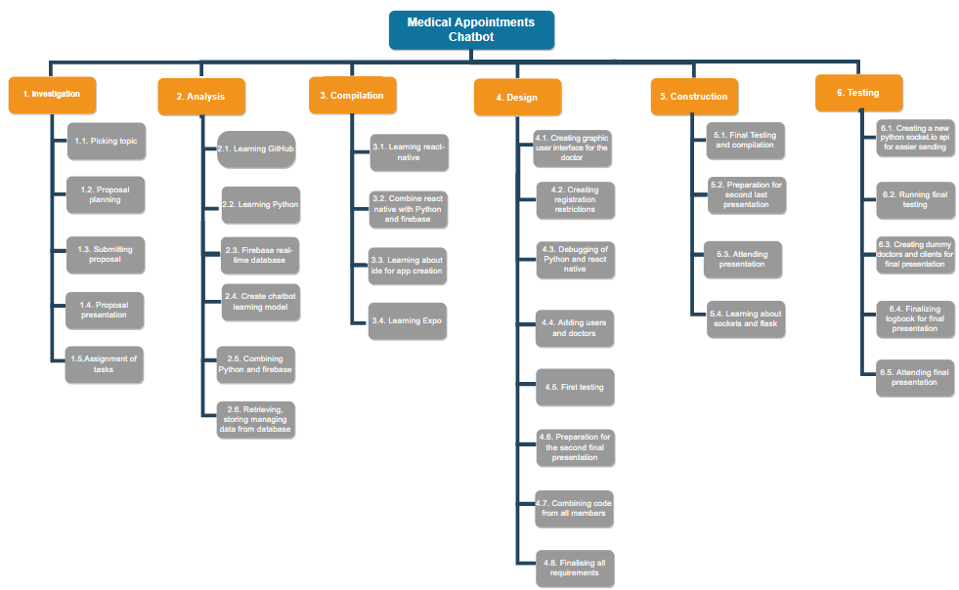

## PERT Chart

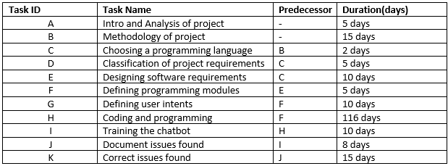

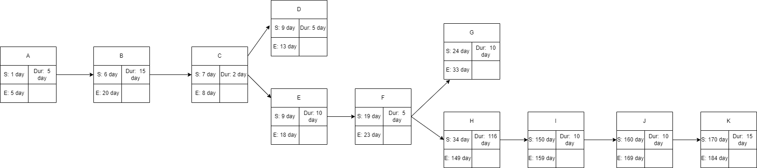

## Gantt Chart

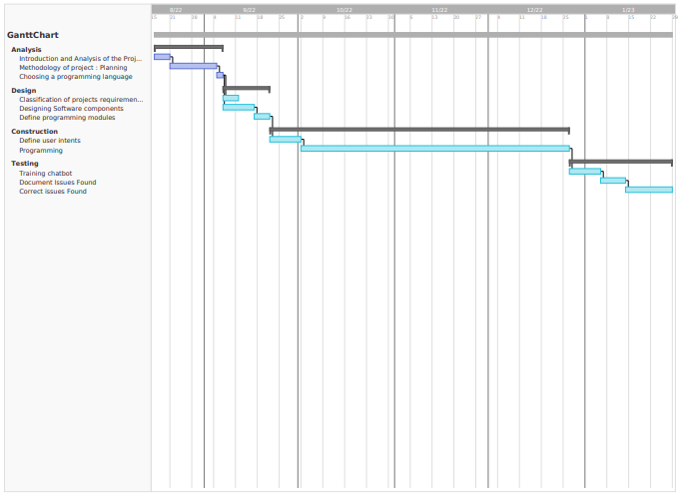

# Modules/Users

## Use Case Diagram

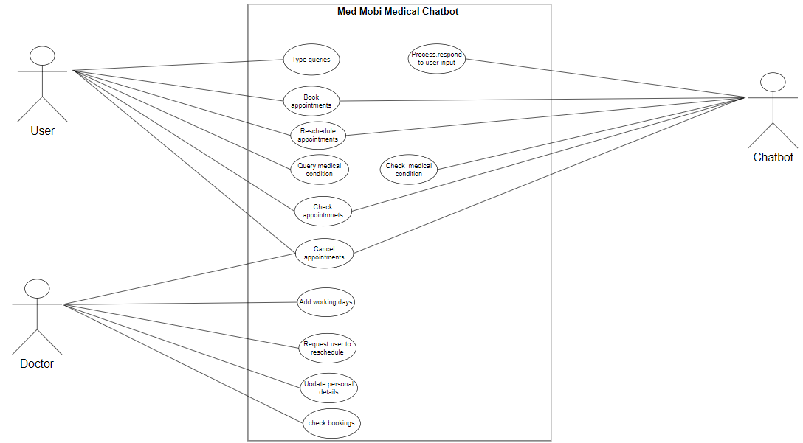

## State Chart

## Data Flow Diagram

# Requirements

## Software Requirements

1. **Flexible internet connections**

The chatbot need to access a real time database for storing fetching and verification of data so it requires good to strong internet connection. The chatbot requires to check user input to understand the intent of the data and send back the most probable answer to the user input.

1. **Multi-platform capability**

chatbot communicates seamlessly across multiple channels such as websites, apps, messenger, phone systems. For a seamless experience, it is also useful if data and context can be stored over several channels. If a customer shares his order, email address or other information with the bot, it can use this input for further actions on other channels. Moreover, it should be possible to pass on all to a live agent if necessary.

1. **Easy handling**

In addition, the chatbot software has to be able to handle the huge amount of data without any problems. It has to be possible to edit corporate identity settings, change and add content quickly, send notifications to employees and have a clear and structured overview of conversations. Well-designed user interfaces and experiences (UI / UX), both on the company and customer side, are essential.

1. **Ongoing optimization**

Every single customer interaction represents a way of learning for artificial intelligence (AI). The more often a chatbot is used, the better it gets because it can access increased data with continuous use. Therefore, a chatbot software should continuously expand its own knowledge base by analysing conversations.

1. **Analytics & reporting**

An outstanding chatbot is an excellent source of data and customer information. However, if you cannot extract it and use it to increase your knowledge, it will be of little use. (Stephanie, July 30th, 2020)

### Functional Requirements

1. **Understand queries.**

Comprehend and understand the query users have, to be able to respond to a query.

1. **Fetching relevant information**

based on the user queries to respond accurately and personalised responses

1. **Provide Fast feedback.**

A chatbot is close simulation of a conversation therefore a quick response is needed and even if the is no response to give a reminder or a response of the ongoing conversation is required.

1. **Providing essential or additional information**
2. **Availability - The system is available all the time.**
3. **Adding Patients.** (Sanjana, 2019)

### Non-Functional Requirements

* + - 1. **User Identification:** The system needs the patient to recognize herself or himself using the phone and adjust, specify, and personalise responses based on the user.
      2. **Administrator rights:** The administrator can view as well as alter any information, as well as practitioners can be able to add information about medication administration and potentially lifestyle adjustment.
      3. **Modifications:** Modifications like insert new practitioner information and new booking information, delete old bookings, update information, and clients.
      4. **Response Time:** The system provides responses fast mimicking a normal human-to-human conversation and have a response for when the conversation is on pause. (Sanjana, 2019)

## Hardware Components

With technology advancing at a rapid rate daily, the use of technology has evolved from a want to need in today’s age, medical chatbot is still one of the simplest software to use online. A client with:

* + 1. Internet Accessible Device - Anybody who has a device that can access good internet connection can access and use this chatbot feely and quickly.
    2. Modern Graphic Accessibility - Any device that can view graphics properly can use this medical chatbot

While creating a chatbot requires extensive knowledge of programming languages(python) and the use of Morden IDE’s, a device, and a device that can use a IDE, will be able to create a working chatbot.

# Advantages

Chatbots are convenient for providing customer service and support 24 hours a day, 7 days a week. They also free up phone lines and are far less expensive over the long run than hiring people to perform support. Using AI and natural language processing, chatbots are becoming better at understanding what customers want and providing the help they need. Companies also like chatbots because they can collect data about customer queries, response times, satisfaction, and so on.(Amplework Software pvt, 2021)

* **Less time spent commuting to the doctor’s office.**
* **Less money spent on unnecessary treatments and tests.**
* **Easy access to the doctor at the push of a button.**
* **Availability 24/7**.

Nothing shows your customers that you are very committed to their experience than being available always. One of the biggest advantages your chatbot can offer you is being there to engage customers at any time of the day, week, month, or year. A chatbot’s 24/7 availability is unmatched, and you will be hard-pressed to find a human employee that will be as available as a chatbot.

* **Lower costs customer service.**

By replacing a human with a chatbot, you can minimize your operational cost. It is difficult for a corporation to hire employees for each role. A single operator can only manage one or two customers at a time, but a chatbot can handle several interactions at once, which is much more when compared with your service or sales team.  can manage. Chatbots help businesses to save a lot of money, while also being easily adaptable to satisfy a variety of needs, depending on the application. (Jake Frankenfiel, 2022)

* **Reduced errors.**

Chatbots help to minimize errors, unfortunately, customer support representatives can do make mistakes (human error) in providing appropriate information to the customers. But the chatbot flow contains pre-written information, intelligent algorithms, and programming, which ensures proper data output. (Elaine Tveit, 2021)

* **Provide faster customer service.**

Chatbots do not take lunch, coffee, or bathroom breaks, they do not nap at their desk, and they don’t wait for someone else to take a turn answering messages. They’re computer programs, which means they have no physical needs or emotions. It also means they can respond almost immediately to customer service requests. They may take a few seconds to analyse a customer’s question or response and determine the appropriate reply, but the wait time is typically not long. (Elaine Tveit, 2021)

* **Can be used as a sales & marketing tool.**

(Abhinav Girdhar, 2022)

# Disadvantages

Chatbots, however, are still limited. Even with natural language processing, they may not fully comprehend a customer's input and may provide incoherent answers. Many chatbots are also limited in the scope of queries to which they can respond. This may lead to frustration with a lack of emotion, sympathy, and personalization given fairly generic feedback. In addition to customer dissatisfaction with not reaching a human being, chatbots can be expensive to implement and maintain, especially if they must be customized and updated often.

* **May not understand user queries.**

To ensure that the chatbot provides the correct information to the customer. It is natural for users’ and businesses’ goals to vary as a result of their engagements. Therefore, the chatbot must be updated with the correct information to meet client demands.

* **Limited responses.**

This challenge is mostly found in chatbots that are not AI-Powered. Some chatbots are rule-based, meaning their responses are limited, and this can be a disadvantage.

Customers could become frustrated when they do not get the right responses and keep getting fed what has been programmed into the chatbot.

* **Lack emotions and its not a personalised experience.**

Chatbots can’t sense when a customer is in distress. They lack empathy and personalization. The lack of emotional reassurance or human connection can cause a customer to seek service elsewhere, which is exactly what you do not want to happen.

* **They can be hard and expensive to install, deploy, set up and maintain.**

Chatbots can take a long time to set up and deploy into the workforce. If they are based on flow builders, you will have to build the chatbot flows from the ground up yourself or hire someone to do it. This process could take months to finish. A chatbot can be time-consuming and tricky to set up. It is a complex program that requires constant maintenance and attention, during both initial deployment and long-term use.

* **Less understanding and natural language**

People in today’s world use shortcut keys to speed up responses and increase efficiency. As a result, chatbots are unable to adapt their language to that of humans. So slang, misspellings, and sarcasm are frequently misunderstood by bots. It means that a chatbot is unacceptable for a friendly discussion.

People in today’s world use shortcut keys to speed up responses and increase efficiency. As a result, chatbots are unable to adapt their language to that of humans. So slang, misspellings, and sarcasm are frequently misunderstood by bots. It means that a chatbot is unacceptable for a friendly discussion.

(Abhinav Girdhar, 2022)

# Conclusion

People in today’s world use shortcut keys to speed up responses and increase efficiency. As a result, chatbots are unable to adapt their language to that of humans. So slang, misspellings, and sarcasm are frequently misunderstood by bots. It means that a chatbot is unacceptable for a friendly discussion.

Inclusion the Healthcare chatbot is gradually eliminating waiting timings at hospitals, appointments, and consultation meetups, and helping patients connect with the right doctor instantly. Healthcare chatbots also give more time to patients to make them understand the treatment. With these features, the chatbot in healthcare brings help to be patient even without visiting a hospital. Healthcare chatbots can save many resources just by themselves, and these resources can help save and treat many more people.

# References

* Jake Frankenfield, May 18, 2022 , Chatbot , from https://www.investopedia.com/terms/c/chatbot.asp
* Stephanie, July 30th, 2020, from https://onlim.com/en/top-requirements-for-chatbot-software/32465
* Abhinav Girdhar, February 16, 2022, from https://www.appypie.com/healthcare-chatbot-advantages
* Amplework Software pvt.ltd, August 12, 2021, from https://www.amplework.com/blog/healthcare-chatbots-pros-challenges-future/
* Konstantin Kalinin, August 12, 2020, from https://topflightapps.com/ideas/chatbots-in-healthcare/
* Elaine Tveit, December 5, 2021, from https://blog.sapling.ai/the-advantages-and-disadvantages-of-using-a-chatbot/
* Zebra Buzz, September 8, 2020, From [https://zebrabuzz.com/advantages-and-disadvantages-of-chatbots/#:~:text=Some%20of%20the%20advantages%20and%20disadvantages%20of%20Chatbots,Use%20Chatbots%20Successfully%20Limited%20Responses%20High%20Installation%20Costs](https://zebrabuzz.com/advantages-and-disadvantages-of-chatbots/)
* Ram Ganesa Athreya, May 06, 2017, Chatbot for Dbpedia, from [GSoC 2017 Proposal - Chatbot for DBpedia (slideshare.net)](https://www.slideshare.net/rexmar5/gsoc-2017-proposal-chatbot-for-dbpedia)
* Sanjana, August 14, 2019, The functional and Nonfunctional requirements requirements for hms, from [The Functional and Nonfunctional Requirement for HMS (mocdoc.in)](https://mocdoc.in/blog/the-functional-and-nonfunctional-requirement-for-hms)